Task 2. Study the advertisement. You are considering repairing your microwave oven and now you’d like to get more information. In 1.5 minutes you are to ask five direct questions to find out about the following:



We repair everything for you!

1. working hours
2. location of the office
3. price
4. if any discounts can be provided
5. how to pay

Task 2. Study the advertisement. You are considering organizing a party for your younger brother and now you’d like to get more information. In 1.5 minutes you are to ask five direct questions to find out about the following:

Have a great party for your children!

1. 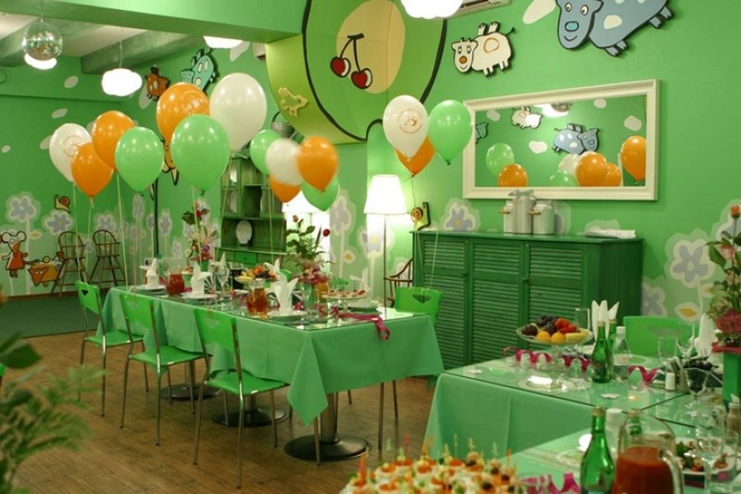age of the children
2. an average price of lunch and dinner
3. if they deliver dishes on their menu
4. entertaining program
5. beforehand booking

Task 2.Study the advertisement. You are considering finding a holiday club for your younger cousin and now you’d like to get **more information. In 1.5 minutes you are to ask five direct questions to find out about the following:**

**Let your children rest with pleasure!**

 1) age of the children

2) working hours

3) entertaining program

4) number of excursions

5) price

Task 2. Study the advertisement. You are considering working on thebeach rolling the passengers on the boat and now you’d like to get more information. In 1.5 minutes you are to ask five direct questions to find out about the following:

1. skills needed Roll your boat!
2. date and time of interview
3. salary
4. working hours
5. office location

Task 2. Study the advertisement. You are considering hiring a motorboat and now you’d like to get more information. In 1.5 minutes you are to ask five direct questions to find out about the following:

Roll your boat!

1. maximum period of hiring
2. day and time to look at
3. trade-mark
4. if any discounts provided
5. office location

Task 2. Study the advertisement. You are considering visiting the TEA HOUSE and now you’d like to get more information. In 1.5 minutes you are to ask five direct questions to find out about the following:

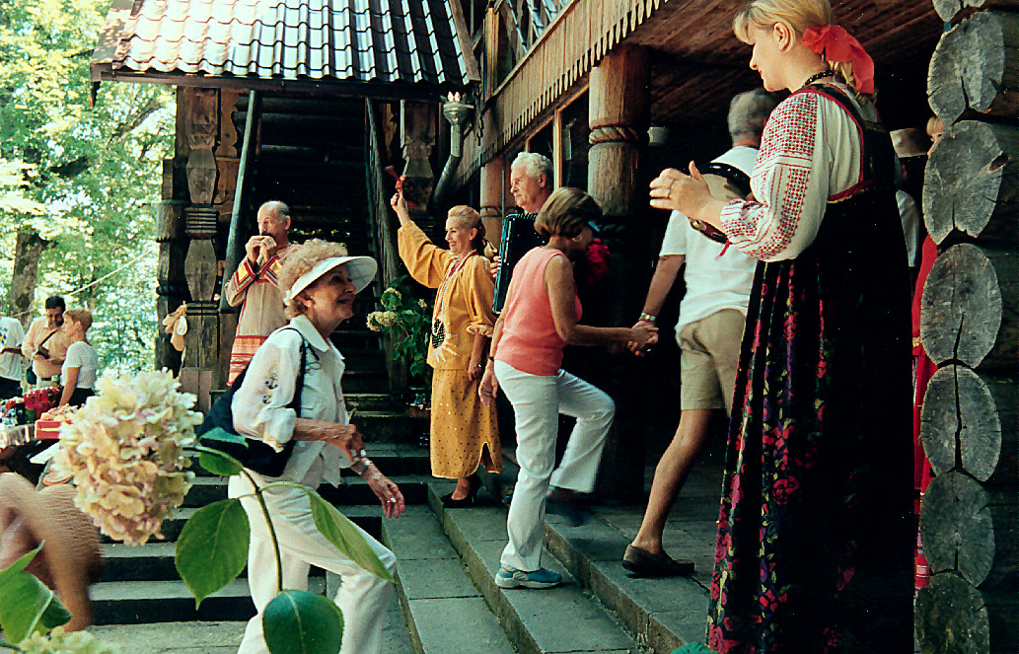1) types of excursions they can offer today The best tea!

2) if there is a discount for groups

3) if you can take photos

4) the schedule of exhibitions

5) the days off

Task 2. Study the advertisement. You are considering finding a holiday club for your younger cousin and now you’d like to get more information. In 1.5 minutes you are to ask five direct questions to find out about the following:

**Let your children rest with pleasure!**



1. club location
2. date to start attending
3. how many days to attend
4. entertainment offered
5. prices

Task 2. Study the advertisement. You are considering visiting a foreign country and now you’d like to get more information. In 1.5 minutes you are to ask five direct questions to find out about the following:

We’ll show you the whole world!



1. kinds of accommodation
2. number of excursions
3. if audio guides are available
4. prices for children and adults
5. discounts

Task 2. Study the advertisement. You are considering visiting a café for children with your younger cousin and now you’d like to get more information. In 1.5 minutes you are to ask five direct questions to find out about the following:

Family Meals

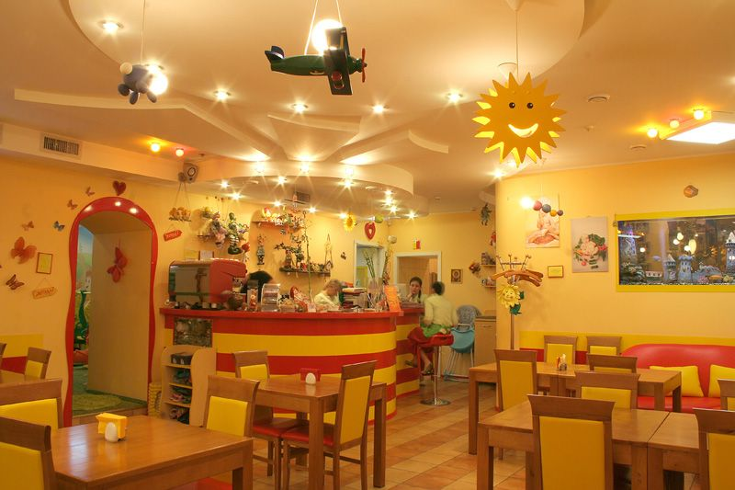

1. location
2. special dishes
3. dishes for vegetarians
4. kinds of drinks
5. live music

Task 2. Study the advertisement. You are considering studying English in Britain and now you’d like to get more information. In 1.5 minutes you are to ask five direct questions to find out about the following:

Practical English. Friendly atmosphere.



1. duration of the course
2. number of lessons per week
3. price of the course
4. lesson duration
5. accommodation

Task 2. Study the advertisement. You are considering studying English apart from your school and now you’d like to get more information. In 1.5 minutes you are to ask five direct questions to find out about the following:

Let’s speak English!

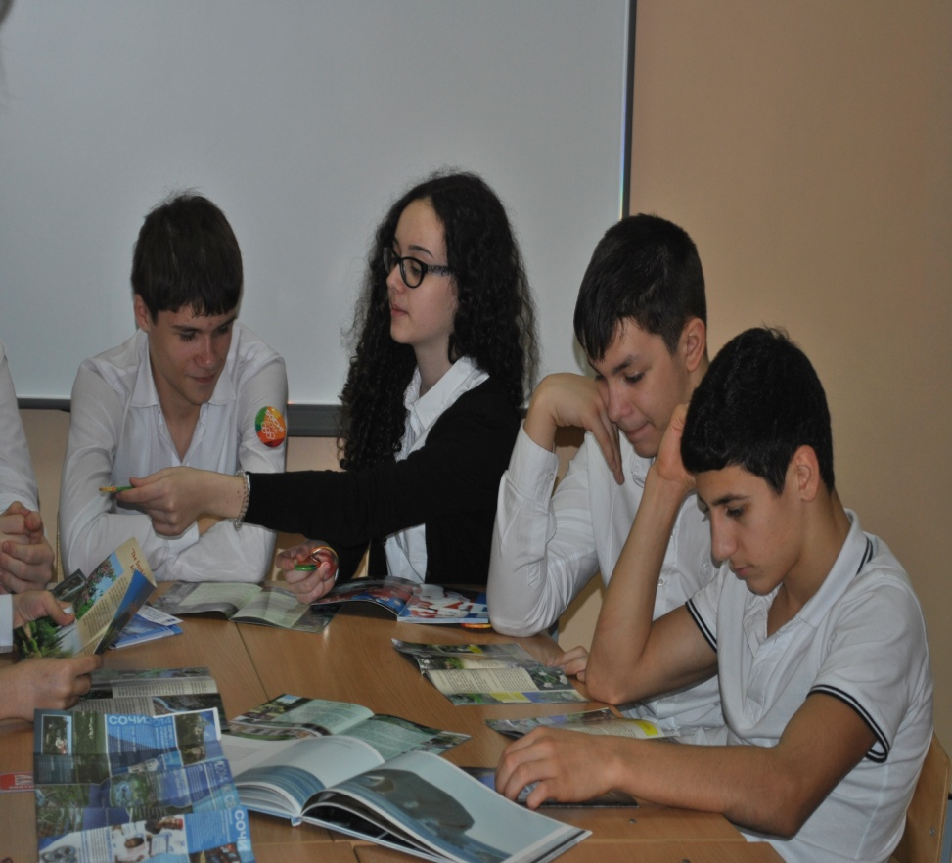

1. if there is free testing
2. if evening classes are available
3. the length of the course
4. possibility to sit Cambridge exams
5. prices

Task 2. Study the advertisement. You are going to have your TV set repaired and now you’d like to get moreinformation. In 1.5 minutes you are to ask five direct questions to find out about the following:

Let your TV set work!

1. working hours
2. location of the office
3. price
4. if any discounts can be provided
5. how to pay

Task 2. Study the advertisement. You are considering visiting a foreign country and now you’d like to get more information. In 1.5 minutes you are to ask five direct questions to find out about the following:

Sightseeing Tours for Everyone!

1. duration of the tour
2. number of excursions
3. guided tour availability
4. price for a three- week tour
5. documents, needed for the journey

Task 2. Study the advertisement. You are considering choosing a swimming pool for your sister and now you’d like to get more information. In 1.5 minutes you are to ask five direct questions to find out about the following:

We offer health for children!

1. 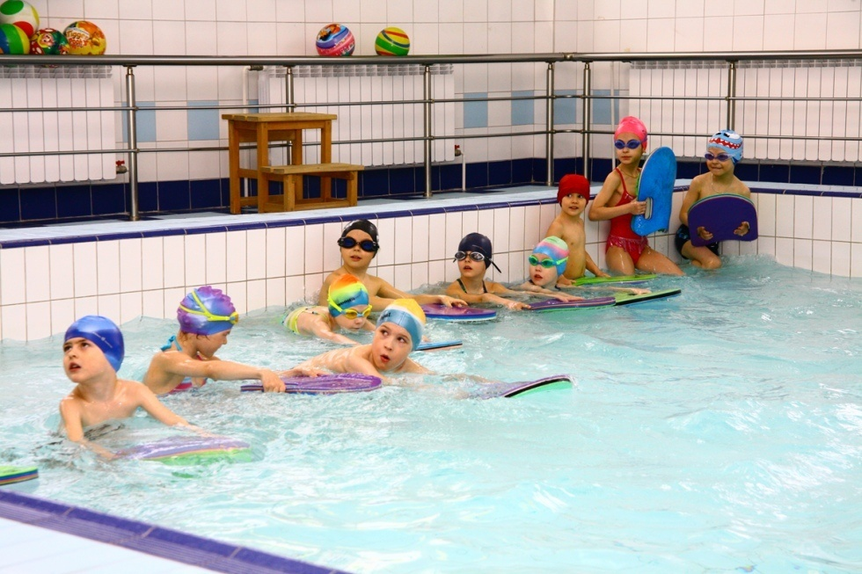location
2. if special clothes needed
3. equipment
4. activities for each age group
5. if doctor’s permission needed

Task 2. Study the advertisement. You are considering visiting a museum and now you’d like to get more information. In 1.5 minutes you are to ask five direct questions to find out about the following:

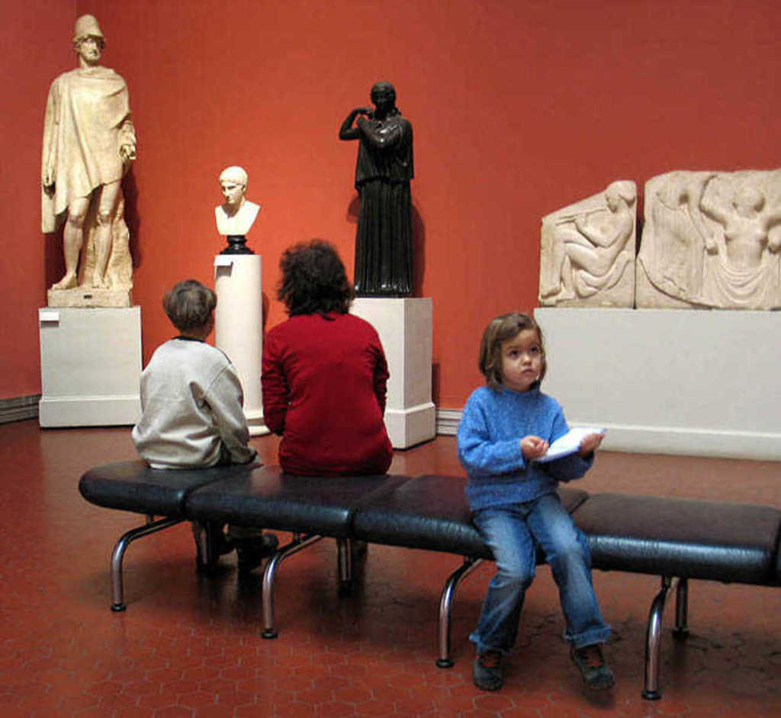 Art for Everyone!

1. opening hours
2. entrance fee
3. discounts for groups
4. photo permission
5. guided excursion availability

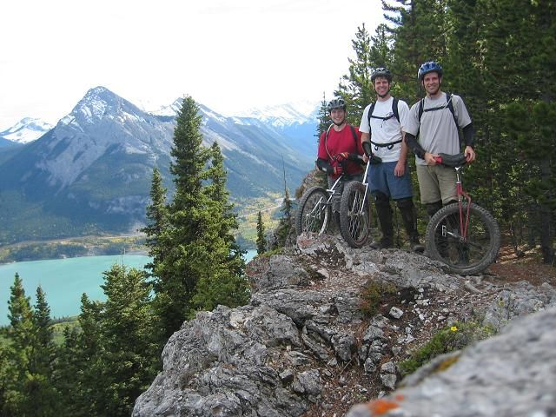 Task 2. Study the advertisement. You are considering mountain cycling and now you’d like to get more information. In 1.5 minutes you are to ask five direct questions to find out about the following:

Enjoy the Beauty of the Mountains!

1. if equipment needed
2. duration
3. guided tour availability
4. documents for the trip
5. age of the tourists

Task 2. Study the advertisement. You are considering having a mountain trip and now you’d like to get more information. In 1.5 minutes you are to ask five direct questions to find out about the following:

Enjoy the Beauty of the Mountains!

1. duration of the trip
2. helicopter tour availability
3. number of people in the group
4. special equipment
5. if doctor’s certificate needed

Task 2. Study the advertisement. You are considering studying English in a foreign country and now you’d like to get more information. In 1.5 minutes you are to ask five direct questions to find out about the following:

1. types of courses available Improve your English with us!
2. possible accommodation
3. documents you will need
4. price for three weeks
5. number of students in the group

Task 2. Study the advertisement. You are considering visiting the coffee shop and now you’d like to get more information. In 1.5 minutes you are to ask five direct questions to find out about the following:

1. special offers
2. discounts for regular customers Enjoy tasty coffee and delicious bakery!
3. most popular coffee
4. if they have a parking lot
5. free Wi-Fi